Justin Davis

4/8/2021

CS 364

LAB 0

1. I plan on using SQL Server. My reason for using SQL Server is because you provided a very good tutorial video showing how to use the basic functions of it, and the only tutorials I could find for Snowflake were generally someone who was really hard to understand, or they would start off speaking English and then go to speaking something else making the tutorial useless to me. I also wanted to use SQL because there wasn’t some signup and fee scheme to it. I first had a functioning DBMS today, 4/8/2021 at about 2pm after fighting with SQL, giving up on it and going to Snowflake, then realizing you had a tutorial on SQL and coming back. I made the tables and put in data the way that was shown in the video, so I didn’t do it via the commands like you showed in the document so I hope that’s alright. Seems to have worked just fine the way I did it.

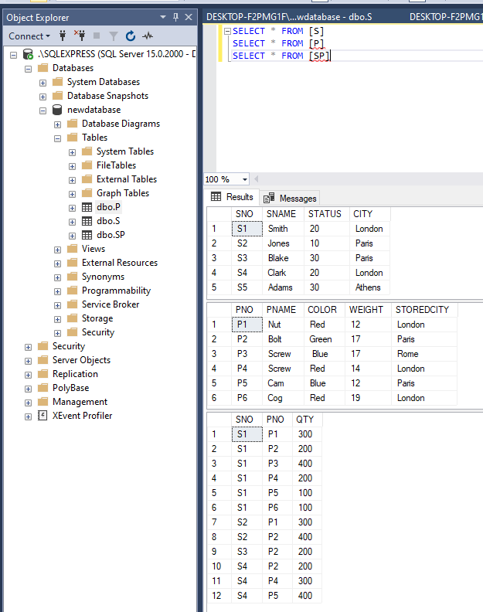I took a smaller section of the system to show the results of my table because it made the picture very hard to read otherwise. There’s just blank space next to this anyway.

I don’t know if it matters, but I couldn’t figure out if the key values were supposed to be underlined like in the assignment write up so I took snips of each tables set up to show that I did actually set the primary keys for each table to the expected values. 